REPORT

Note to Self

Objective:

We all have secrets. Secret in mind is a burden. Sometimes we need a place to tell what's on mind frankly.

This is a blank place where you can express yourself and talk to yourself secretly. You can write anything as if you talk to yourself, and let them go.

Jot down ideas, take a memo, and take notes without decorated happiness or showing off. It will unburden yourself and you can feel better.

All thoughts, feelings and plans written down are archived as your own story. Only you can read them anytime later on.

FEAUTURES:

**1.Login / Sign in:**

Initially our Home page will be displayed on to one’s screen on loading our website on one’s system. All the login and sign in Data and safely stored into our reglog database . If you open any Note to Self features without Login that redirects to Login page If you already have an Note to Self account, then you can log in otherwise you can sign in and your information and then you can login to access the features of Note to Self.

Sign in:

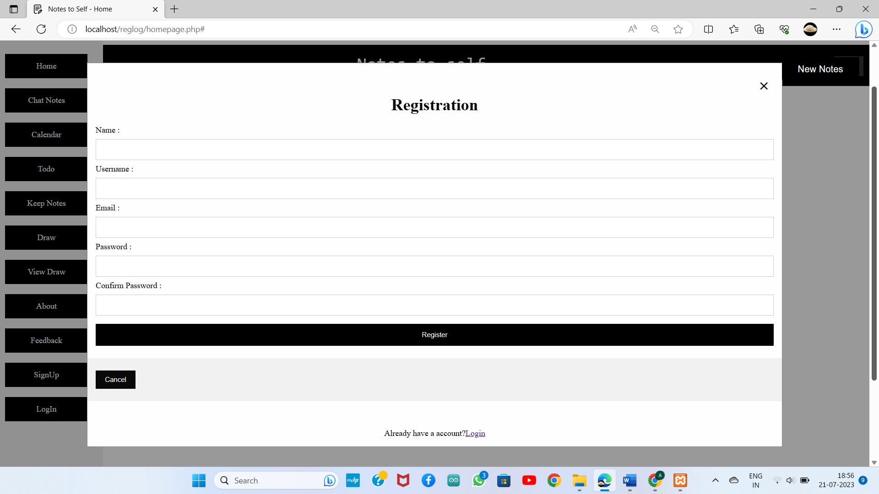

Log in:

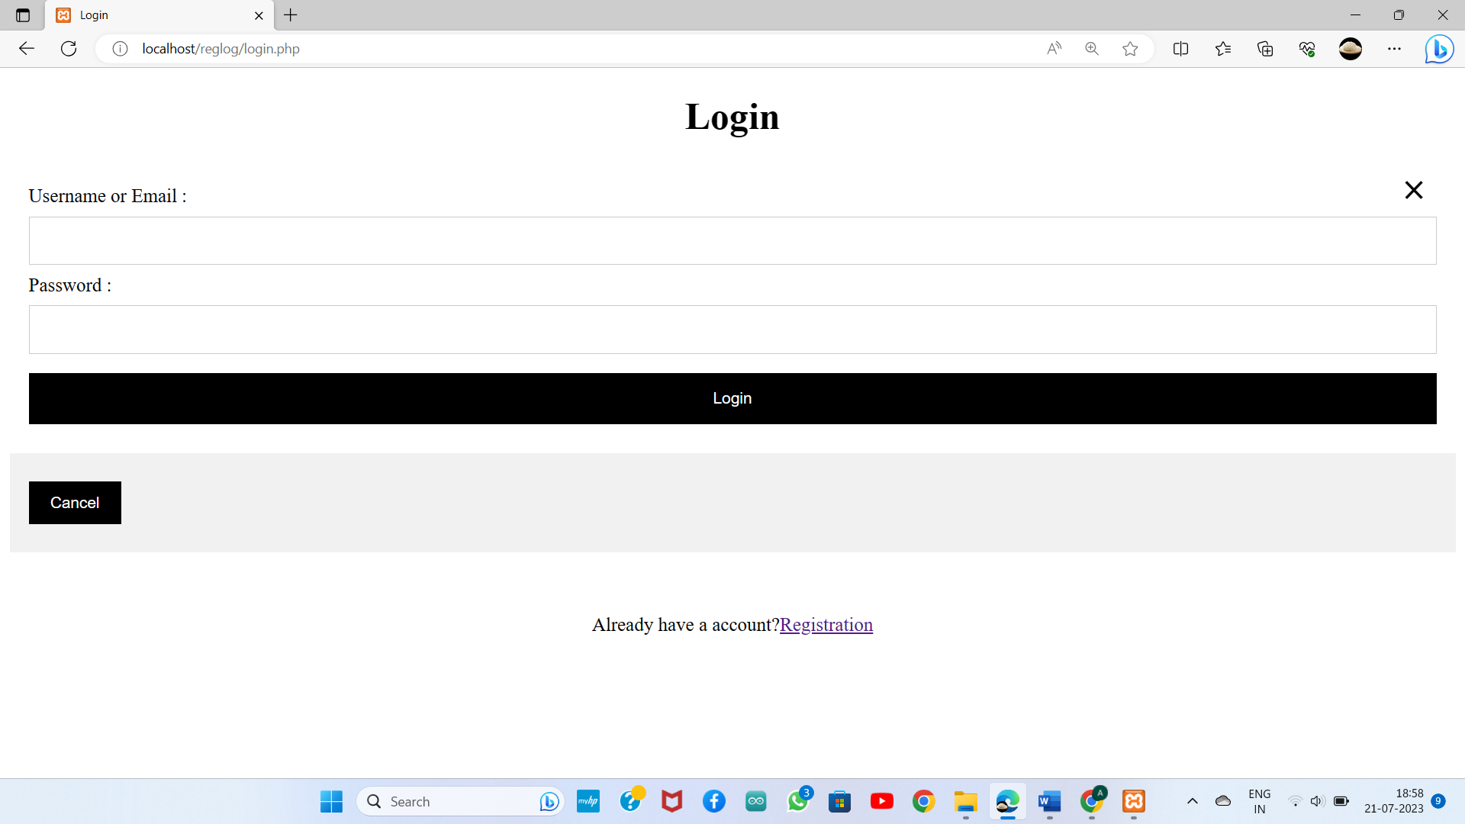

**2.Home page:**

The Home page that has Menu button if you touch it side menu navigation will open from left side. In that side menu user can traverse over the features of the **Note to Self**. Currently there are 3 features in Home page.

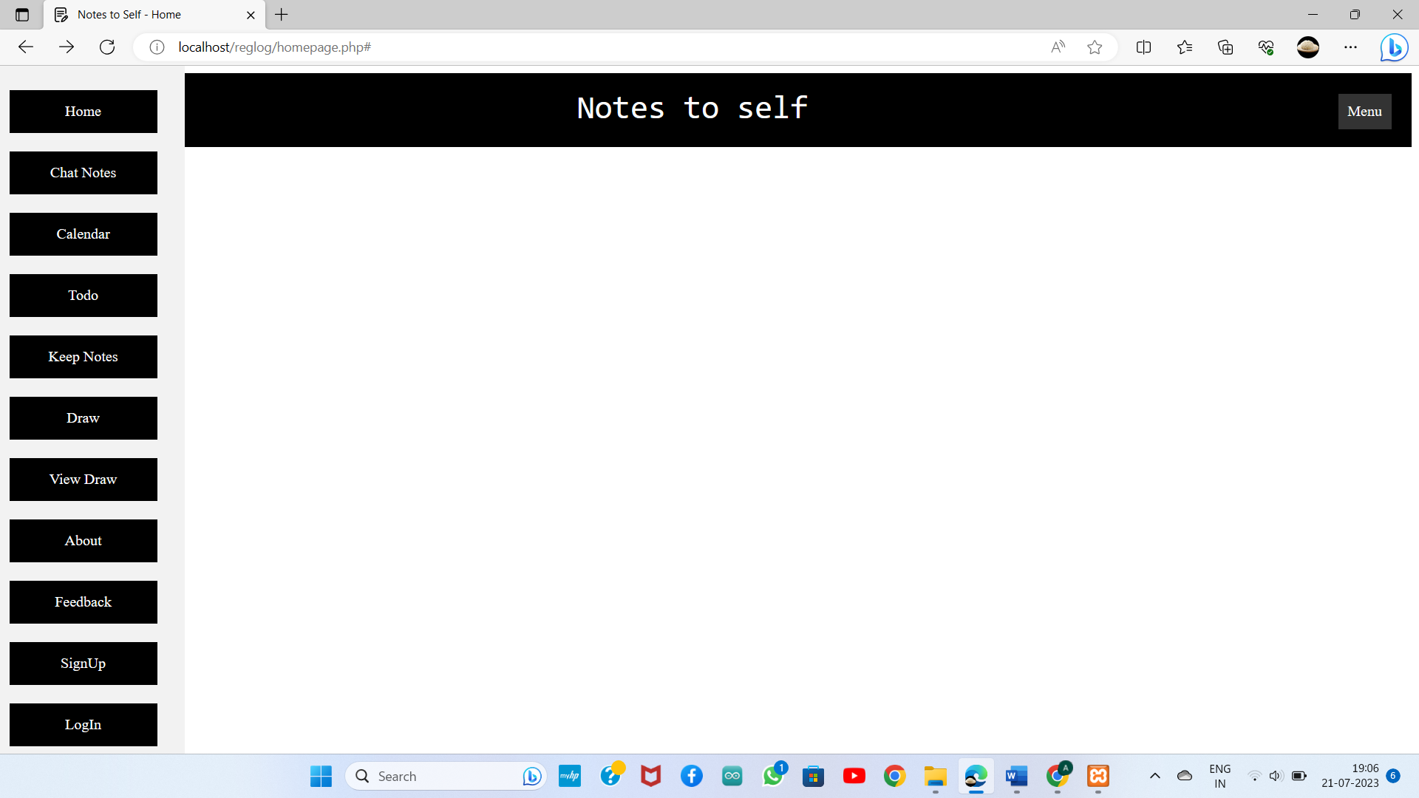

**3.Chat Notes:**

In chat interface that new notes button, by clicking New Notes

User can create Notes Title and Description of the notes.

By chat this chat interface user can type their Secrets

Send. User can create more notes title and send the

secrets. User can change the theme.

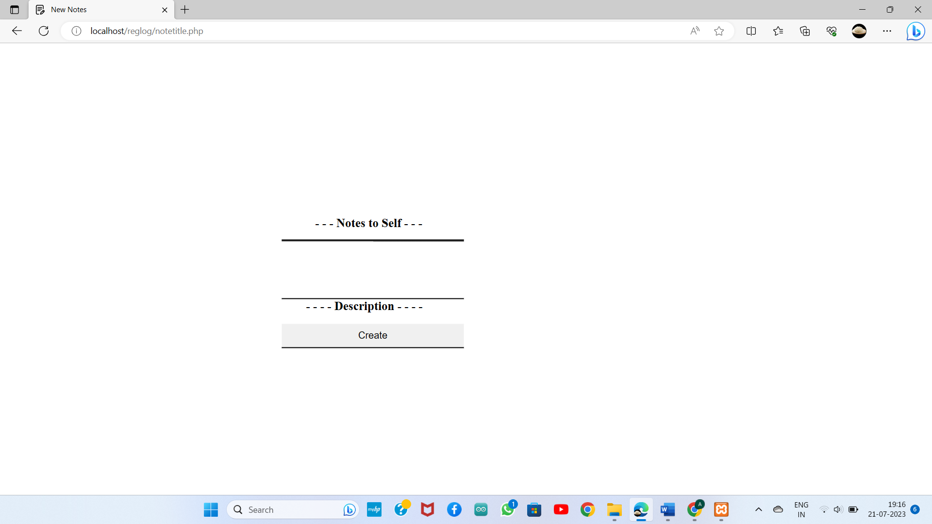

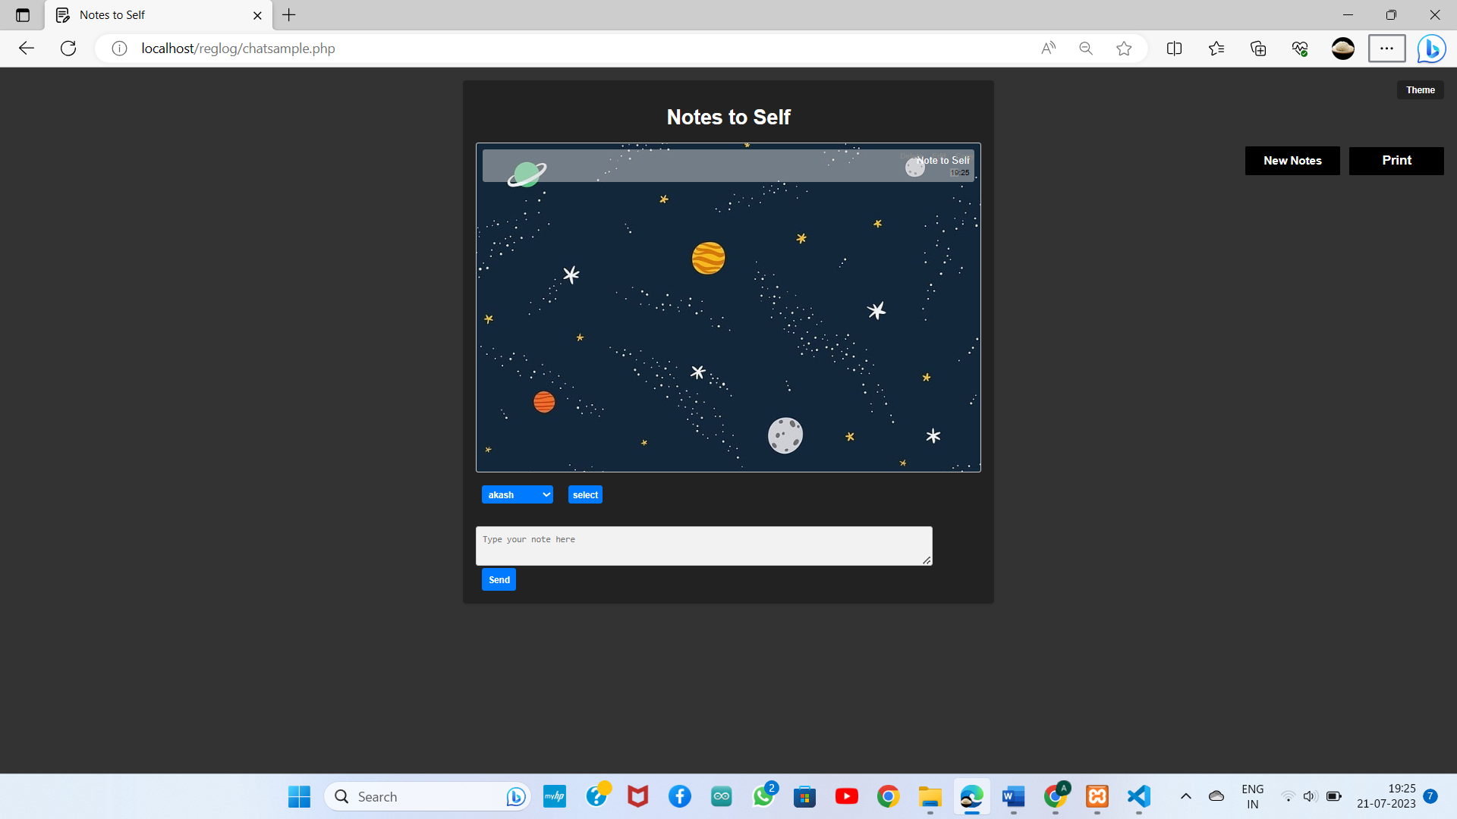

**4.Calander:**

User can add the events and view the events later.

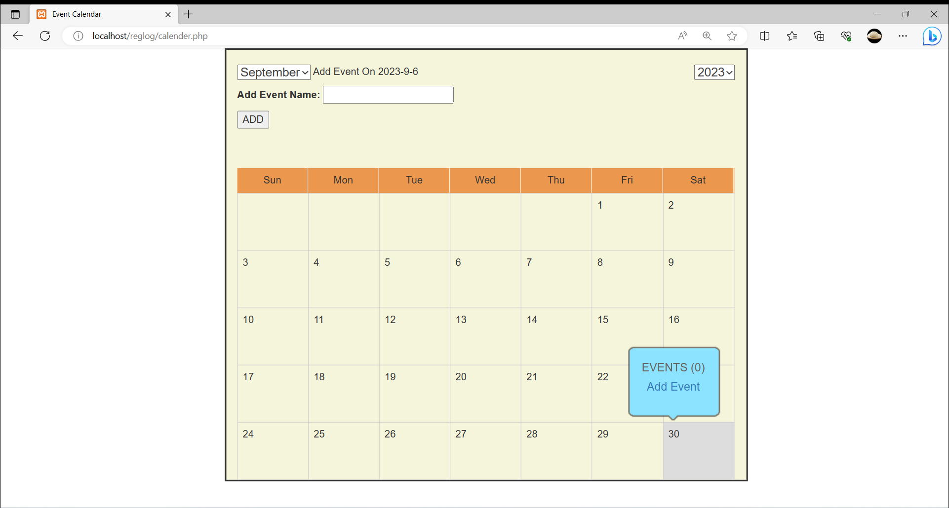

5.**To Do List:**

User can add to do list of the day, if it is completed user can strike through it and it has delete option to delete to do.

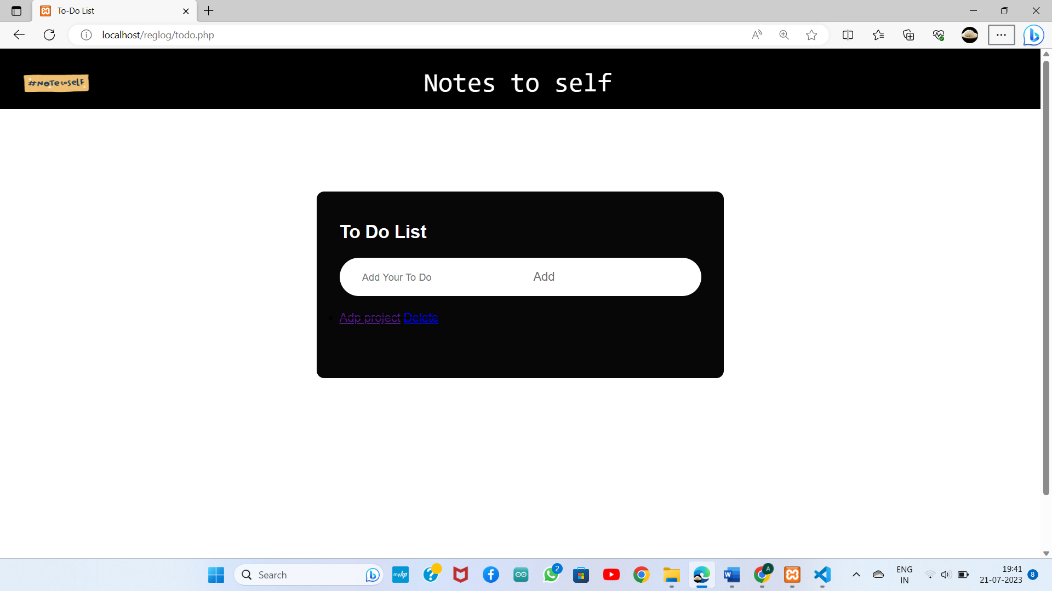

**Languages Used:**

1.HTML :

Hypertext Markup Language is used to create a webpage

2.CSS :

Cascading Style Sheets is used to give styles to webpage

3.JAVA SCRIPT :

JavaScript is used to create dynamically updating content, control multimedia, and pretty much everything else

**Complete overview:**

The home page with 3 features like chat notes, to do, calendar. For 50% completion of project login and sign up page is completed with user data stored in database. For chat note only chat interface is created using html , css, java script, calendar with moths of this year

**AKASH -2022503041**

**KAVINSAI - 20222503553**